Department of Computer Science and Applications
Department Activities Session 2023-24
- Department of Computer Science and Applications, A.S. College, Khanna signed an MoU with Ansh Infotech, Ludhiana, through which the company will provide the trainings on latest technologies and will help the students to prepare themselves for better placements. This MoU will strengthen the Industry-Academia Interface is the need of the hour. [PIC I]
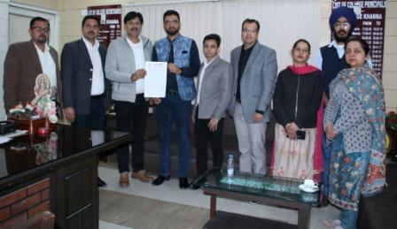
- The Computer Association of department of Computer Application of A.S. College Khanna organized an Extension Lecture on Cyber Security on 23rd Feb. 2024. The team members from Ansh Infotech, Ludhiana Mr. Anshu Aneja, Mr. Ashish Jalota and Mr. Gobind Singh delivered the lecture on latest trends in Cyber Security.
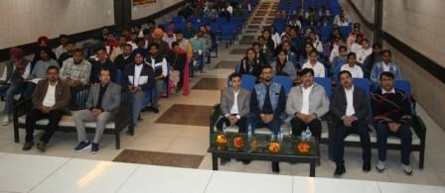

- Department of Computer Science of A.S.College, Khanna organized Inter Department IT Fest Synergy 2024. The event comprised of various competitions like Live Model Demonstration, Poster Competition and Test Your Programming Skills based on the theme of Information Technology and Environment. The students of BCA, BA/B.Sc (Computer Applications) participated in the event The results of the event are: {PIC III,IV}
Live Project: First: Parvesh Sharma, Navdeep Singh, Mohit, Indervir Singh [BCA III]
Second: Arshpreet Singh, Baljeet Singh [BCA I]
Still Project: First: Parchi Sharma, Vanshika, Meenakshi [BCA I]
Second: Janvi, Manya, Purnima [BCA II]
Third: Harshita, Lovepreet Kaur, Simaranjeet Kaur [BCA III]
Poster Making (Information Technology): First: Kritika Sharma [BCA I]
Second: Shekhar [B.Sc III], Variender [BCA III]
Third: Sheetal [BCA II], Roshni [BA I]
Poster Making (Environment): First: Danish [BCA II]
Second: Madhu [BCA I], Sukhdeep Singh [BCA II]
Third: Simaranjeet KAur [BA II] , Lakshay [BCA II]
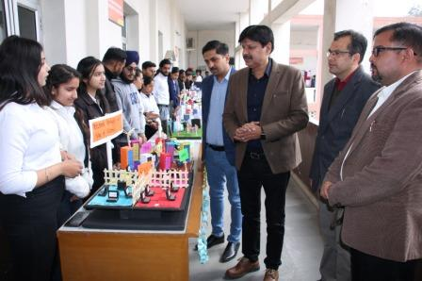

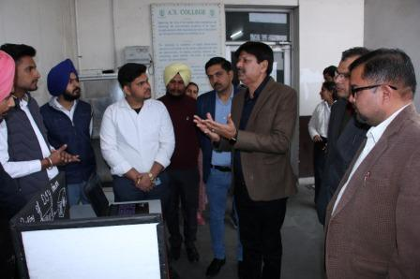

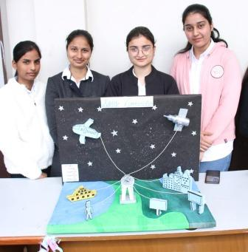
- Ramandeep Kaur, Student of B.Voc Multimedia (Graphics and Animation) secured First Position in Panjab University and was honoured with Gold Medal. She was honoured in 71st Convocation of Panjab University held on 7th March, 2024.
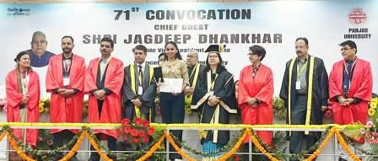

- The students of the department participated in Swaach Bharat Campaign on 2nd October, 2023. The students helped the IV class employees in cleaning the department and helped the Technical Staff in cleaning and maintain the hardware in labs and encouraged all the students of the college to dispose off the e-waste properly.
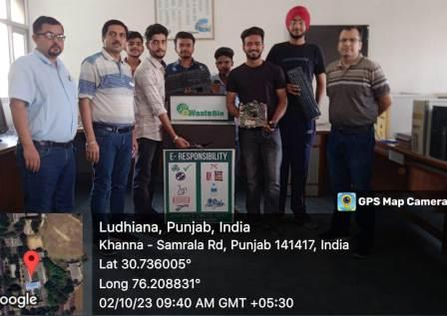

- The students of A.S.College, Khanna attended Virtual Session organized by Akhil Bhartiya Shiksha Samagam (ABSS) on 3rd anniversary of National Education Policy 2020 organized at ITPO, Pragati Maidan, New Delhi on 29th July 2023. The students got the opportunity to know the views of Honourable PM of India Sh. Narender Modi. He shared the milestones achieved till now for the implementation of NEP in India, and also threw light on the future roadmap. He emphasized on the fact that students are foundation of India’s future and motivated them to go for skill based, interdisciplinary and multilingual course framework. Students can go beyond the barriers of language and can study any course in their regional language also. The session was attended by around 103 students, and 10 teaching and non teaching staff members.

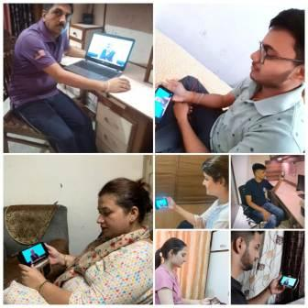
- 100 students of the Department participated in the event and got certificates. Participated in Online Quiz on Mobile and Mobile App Security Organized as a part of Stay Safe Online Campaign Under India’s G20 presidency. The campaign is led by Ministry of Electronics and Information Technology (Meity), Government of India from 16th September to 31st October, 2023.

- The department organized one day trip to Brog Valley and Pinjore Gardens on 17th March, 2024. 50 Students accompanied by Dr. Vivek Bhambri, Dr. Anil Kumar, Prof. Poonam and Mr. Dalvir Singh felt rejuvenated after the visit to hilly areas. [PIC VIII]
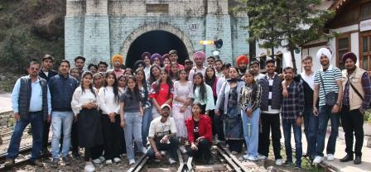
- To mark completion of 25 Years of the department, an event was organized on 09th April, 2024 to begin the Silver Jubilee Year Celebrations. Various activities involving the alumni of the department and present students has been planned through out the year. Officiating Principal Dr. K.K.Sharma released the logo of Silver Jubilee Year. This logo has been designed by the Alisha, Student of BCA III. Sukhjinder Singh [BCA III], Prachi Sharma and Vanshika of BCA I shared their views about the College and the department. Taranpreet Kaur and Garima of BCA II presented melodious songs. Prizes were distributed to the students participated in various events conducted by the department in Session 2023-24. Cake cutting ceremony was also organized in the event.
